SYSTEM DESIGN
5.1 SYSTEM ARCHITECTURE DESIGN:
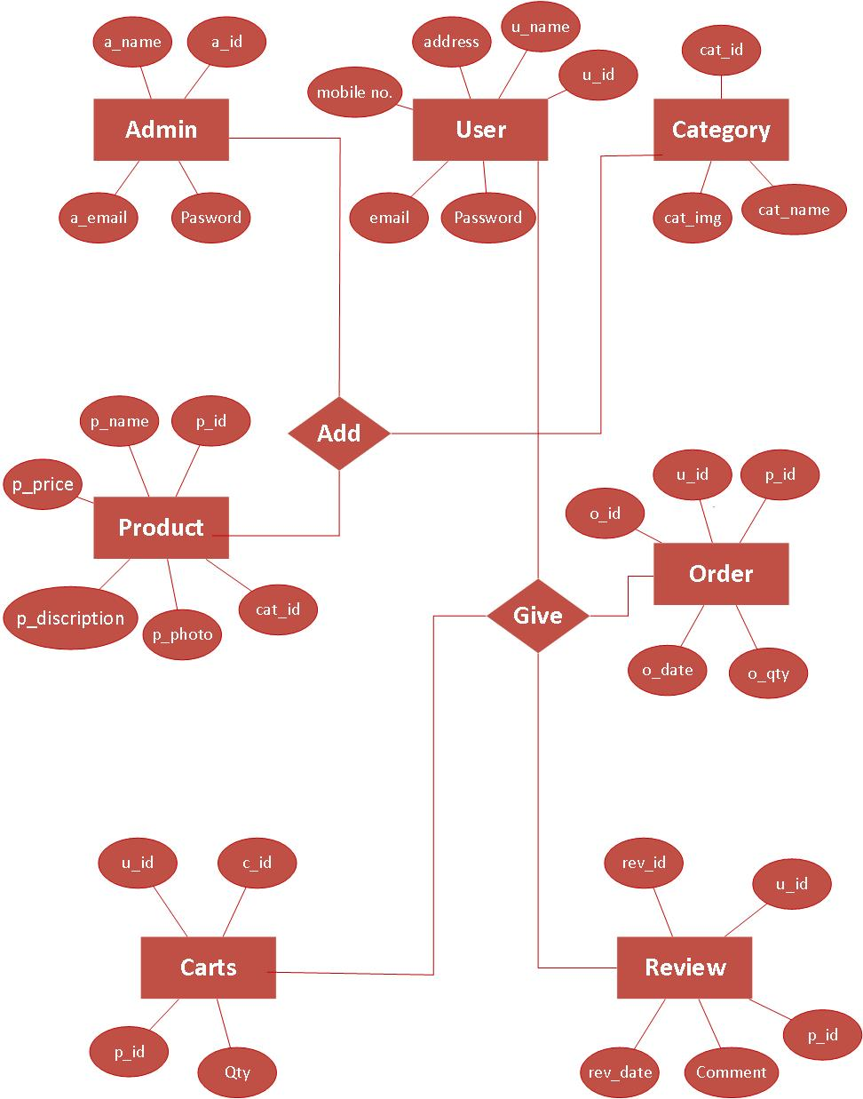 Figure 5.1: E – R Diagram

5.1.2 Use case Diagram:
- Admin:

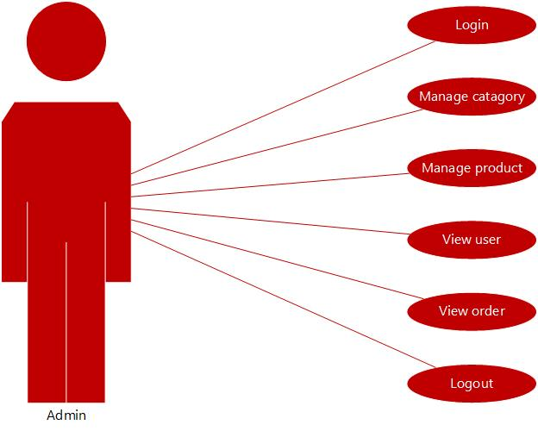
Figure 5.2: Use case Diagram for Admin

- Register:

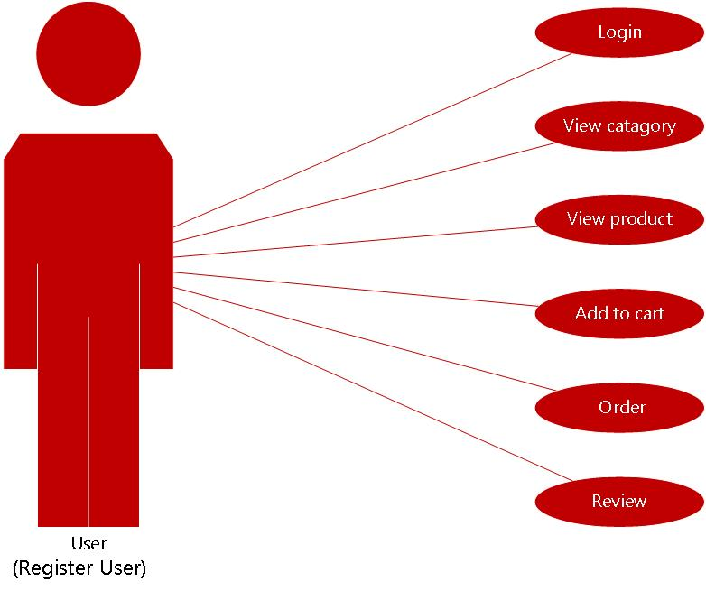

Figure 5.3: Use case Diagram for register

- Visitor :

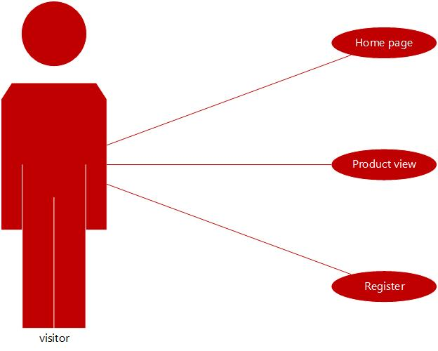
Figure 5.4: Use case Diagram for Visitor

5.1.3 Data Flow Diagram:
          - Context Diagram :
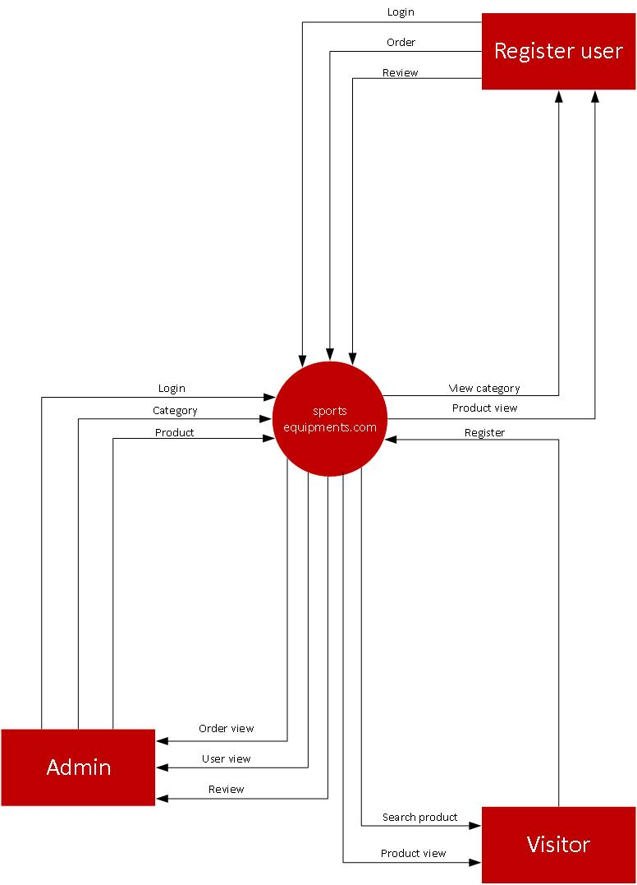
Figure 5.6: Context Diagram
Level 1 Data Flow Diagram :
A)Admin:
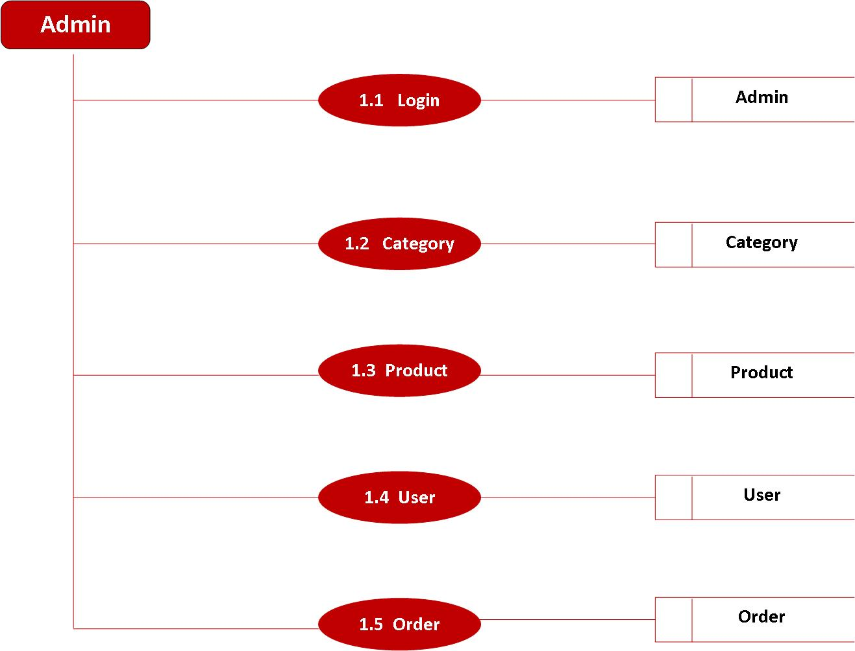

Figure 5.6: 1 - Level Data Flow Diagram

B)Vsitor:

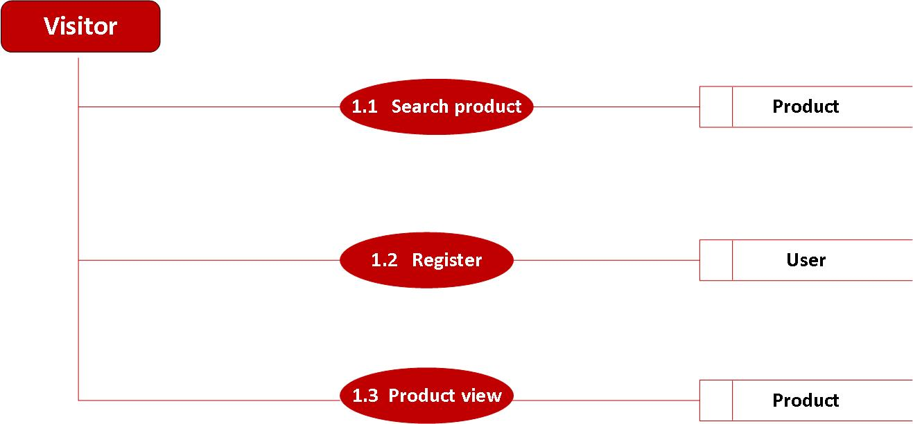

Figure 5.6: 1 - Level Data Flow Diagram

C)User:
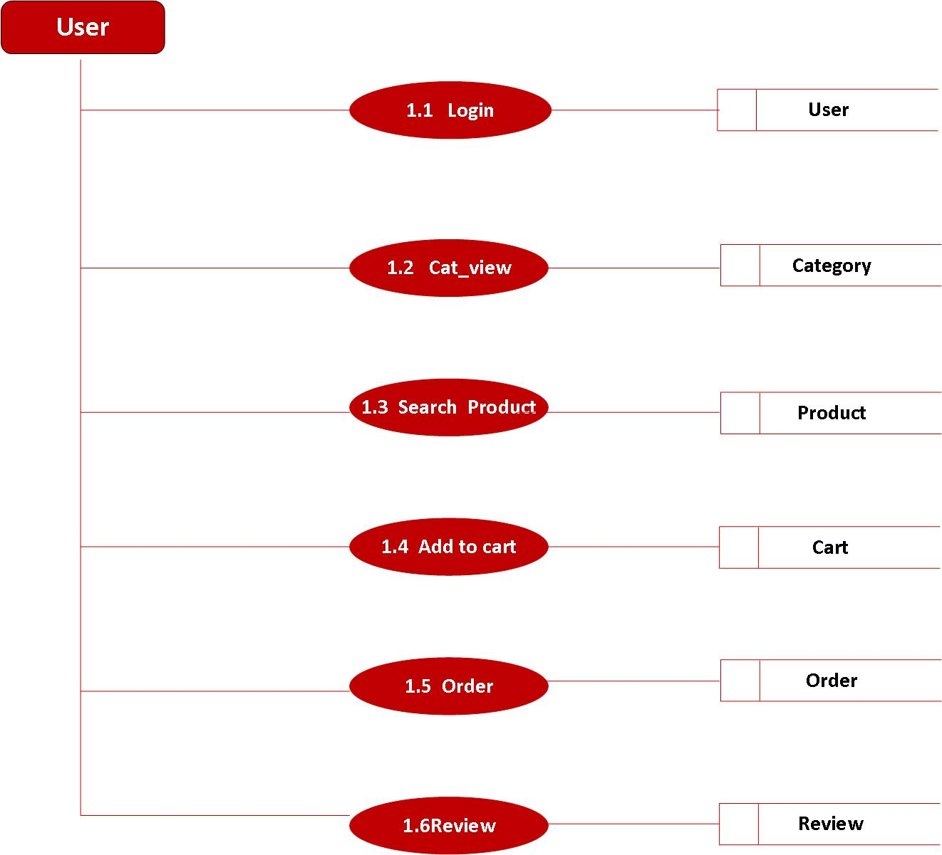
Figure 5.6: 1 - Level Data Flow Diagram

    - Activity Diagram :

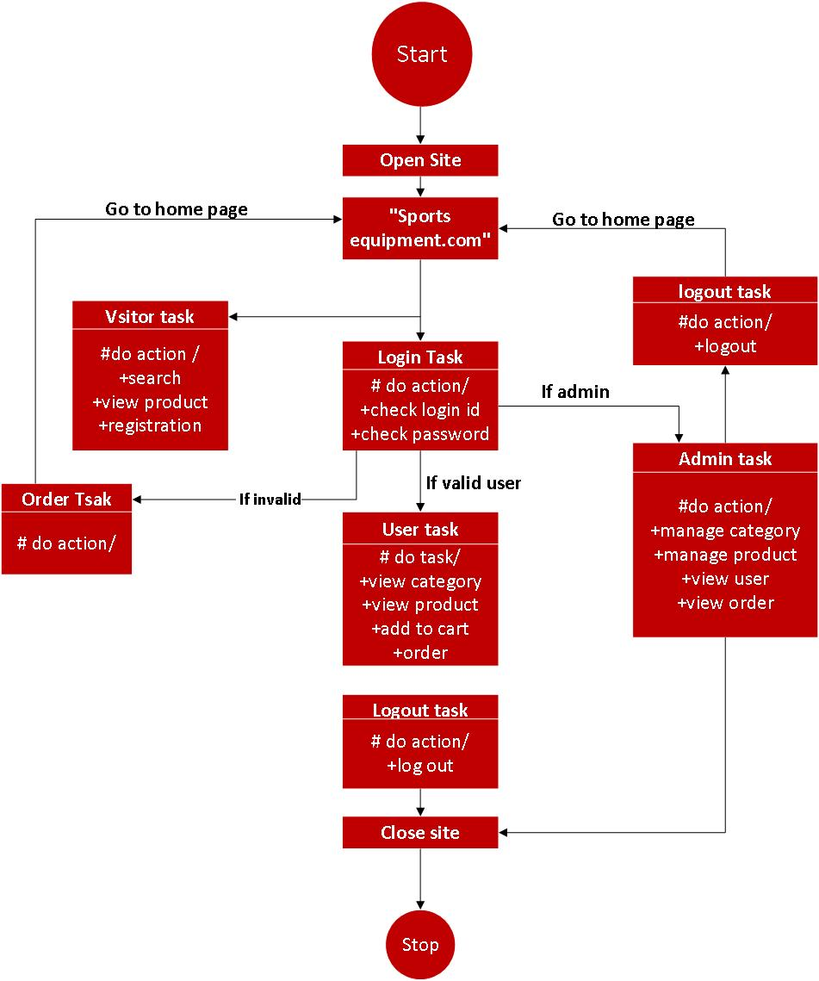 Figure 5.7: Activity Diagram
5.2 DATA DICTIONARY
Table Name: Admin
Description: This is table contains the Admin Details.
SR. No | FIELD NAME | DATA TYPE | SIZE | CONSTRAINT | DESCRIPTION
1 | a_id | Int | 10 | Primary key | Id of admin
2 | a_name | Varchar | 20 | Not null | Name of admin
3 | Email | varchar | 30 | Not null | Email of admin
3 | Password | varchar | 10 | Not null | Password of admin

Table Name: Users
Description: This is table contains the User Details.
SR. No | FIELD NAME | DATA TYPE | SIZE | CONSTRAINT | DESCRIPTION
1 | U_id | Int | 10 | Primary key | Id of user
2 | U_name | Varchar | 20 | Not null | Name of user
3 | Address | Med_text |  | Not null | Address of user
4 | Mobile_no | Varchar | 10 | Not null | Mobile no. of user
5 | E-mail | varchar | 30 | Not null | e-mail of user
6 | Password | varchar | 10 | Not null | Password of user

Table Name: Products
Description: This is table contains the Products Details.
SR. No | FIELD NAME | DATA TYPE | SIZE | CONSTRAINT | DESCRIPTION
1 | p_id | Int | 10 | Primary key | Id of admin
2 | p_name | Varchar | 20 | Not null | Name of product
3 | p_prise | Int | 10 | Not null | Prise of product
4 | p_description | Med-text |  | Not null | Description of product
5 | P_photos | varchar | 50 | Not null | Photo of product
6 | Cat_id | Int | 10 | Not null | Id of category

Table Name: Orders
Description: This is table contains the Orders Details.
SR. No | FIELD NAME | DATA TYPE | SIZE | CONSTRAINT | DESCRIPTION
1 | O_id | Int | 10 | Primary key | Id of Order
2 | u_id | Int | 10 | Not null | Id of user
3 | P_id | Int | 10 | Not null | Id of product
4 | O_Qty | Int | 10 | Not null | Qty of product
5 | O_date | Date |  | Not null | Date of order

Table Name: Carts
Description: This is table contains the carts Details.
SR. No | FIELD NAME | DATA TYPE | SIZE | CONSTRAINT | DESCRIPTION
1 | C_id | Int | 10 | Primary key | Id of cart
2 | U_id | Int | 10 | Not null | Id of user
3 | P_id | Int | 10 | Not null | Id of product
4 | Qty | Int | 10 | Not null | Qty of product

Table Name: Reviews
Description: This is table contains the Reviews Details.
SR. No | FIELD NAME | DATA TYPE | SIZE | CONSTRAINT | DESCRIPTION
1 | Rev_id | Int | 10 | Primary key | Id of review
2 | u_id | Int | 10 | Not null | Id of user
3 | P_id | Int | 10 | Not null | Id of product
4 | Comment | Med-text |  | Not null | Comment on a product
5 | Rev_date | Date |  | Not null | Date of Review

Table Name: Categorys
Description: This is table contains the Cetegorys Details.
SR. No | FIELD NAME | DATA TYPE | SIZE | CONSTRAINT | DESCRIPTION
1 | Cat_id | Int | 50 | Primary key | Id of category
2 | cat_name | varchar | 20 | Not null | Nameof category
3 | Cat_img | varchar | 50 | Not null | Imagec of category
5.3 Sample code:
Login Design:
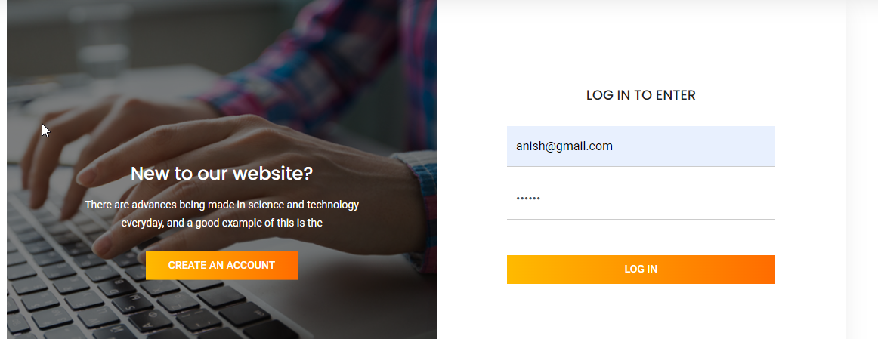

Login.php

<html>
<body>
<section class="login_box_area section_gap">
<div class="container">
<div class="row">
<div class="col-lg-6">
<div class="login_box_img">
<img class="img-fluid"src="img/login.jpg"alt="">
<div class="hover">
<h4>New to our website?</h4>
<p>There are advances being made in science and technology everyday, and a good example of this is the</p>
<a class="primary-btn" href="register.php">Create an Account</a>
</div>
</div>
</div>
<div class="col-lg-6">
<div class="login_form_inner">
<h3>Log in to enter</h3>
<form class="row login_form" action="login-code.php" method="post" id="contactForm" novalidate="novalidate">
<div class="col-md-12 form-group">
<input type="email" class="form-control" name="email" placeholder="Email" onfocus="this.placeholder = ''" onblur="this.placeholder = 'Username'">
</div>
<div class="col-md-12 form-group">
<input type="password" class="form-control" name="password" placeholder="Password" onfocus="this.placeholder = ''" onblur="this.placeholder = 'Password'">
</div>
<div class="col-md-12 form-group">
<div class="creat_account">
</div>
</div>
<div class="col-md-12 form-group">
button type="submit" value="submit" class="primary-btn">Log In</button>
</div>
</form>
</div>
</div>
</div>
</div>
</section>
</body>
</html>
5.4 SCREENSHOT
- VISITOR SIDE:
  - Home Page
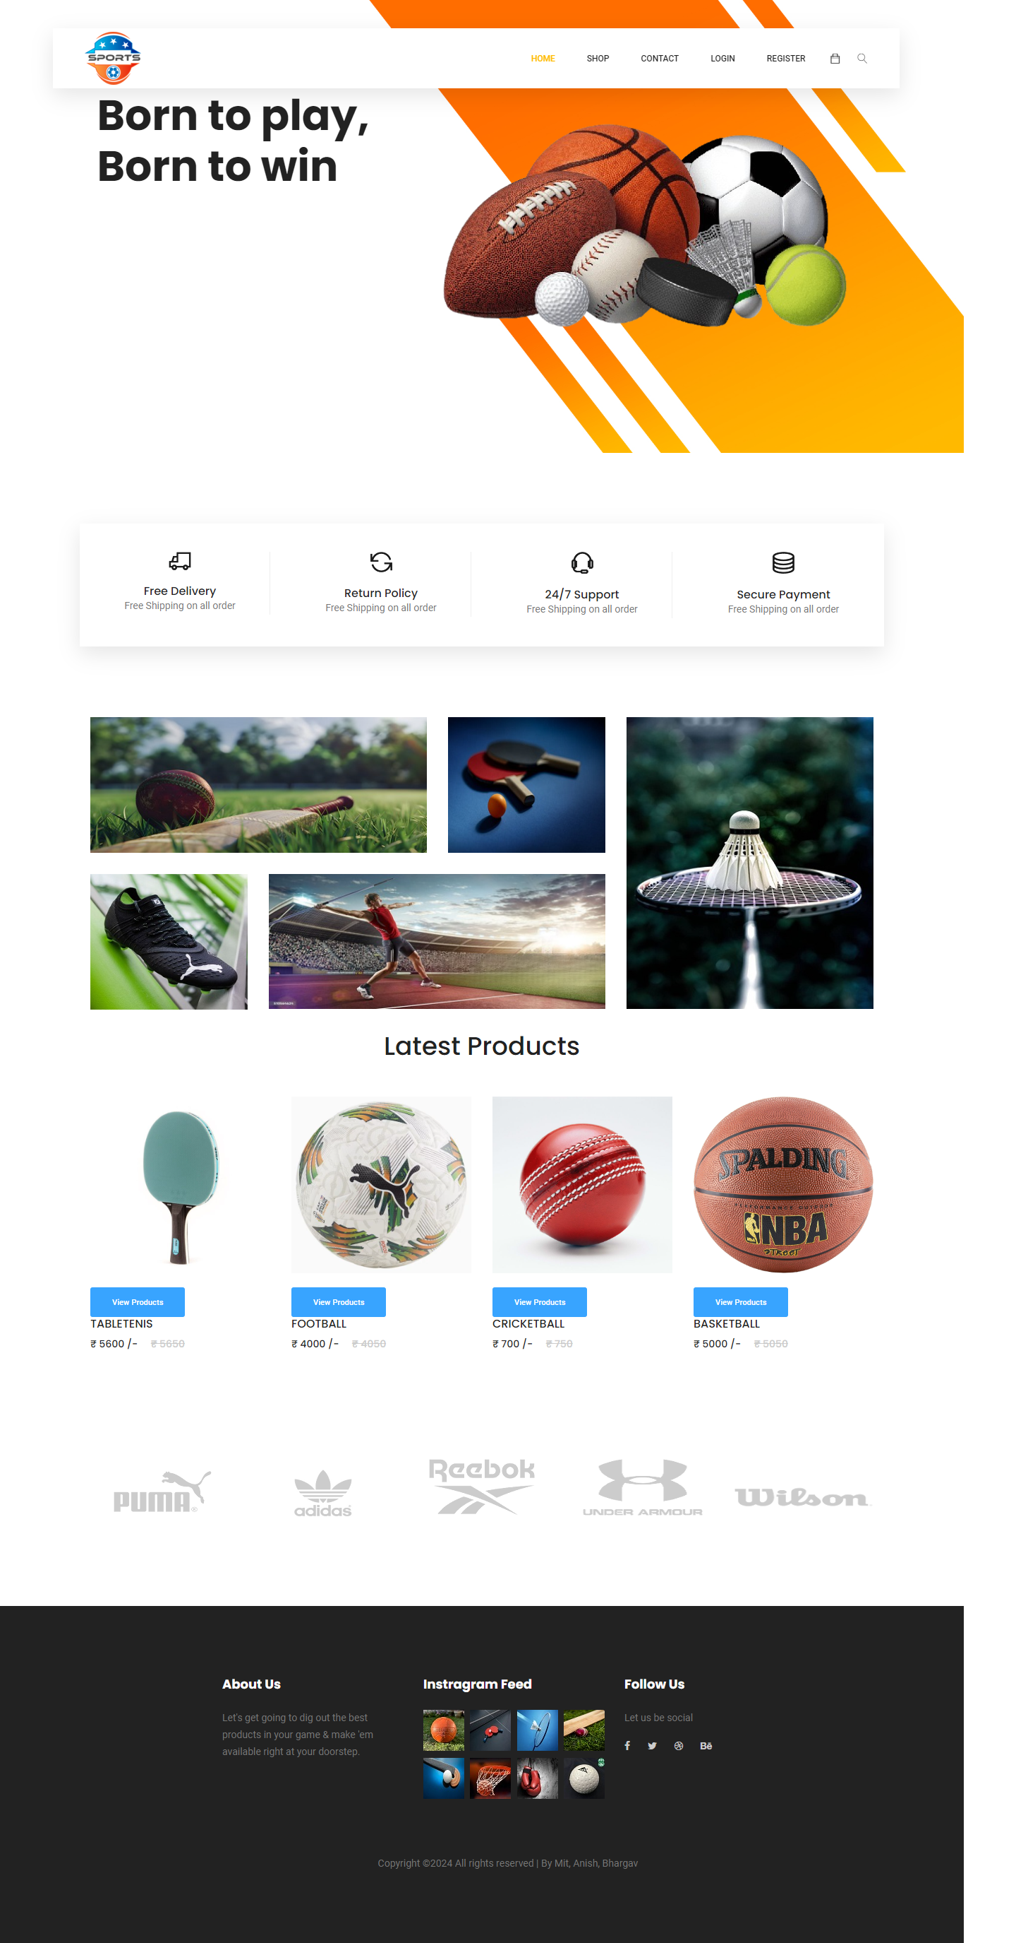
This is the home page of our website.

1.2 Shop Category Page:
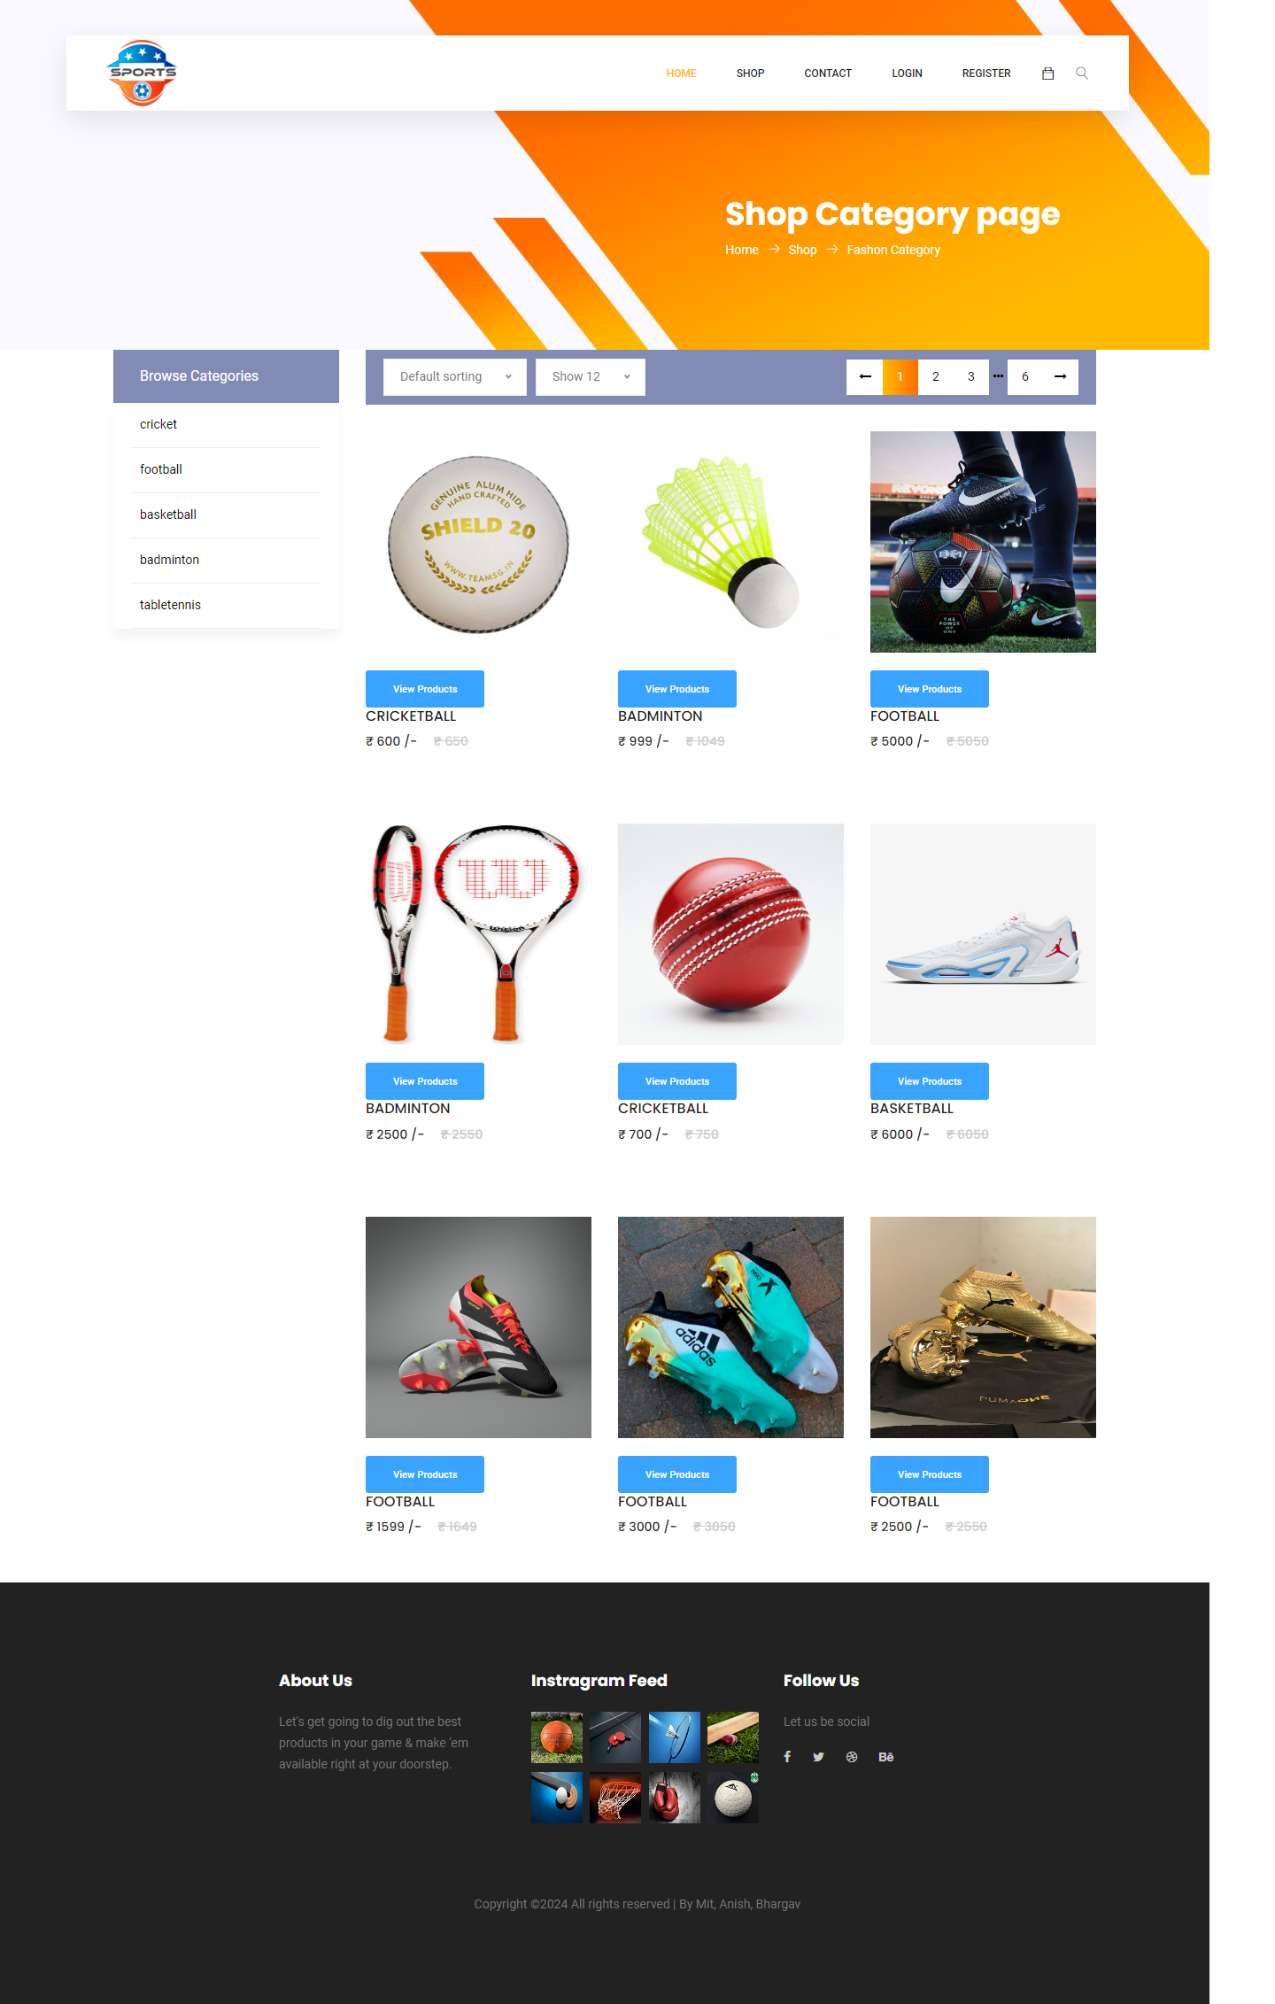
This is the shop page of our website.
1.3Product details Page:
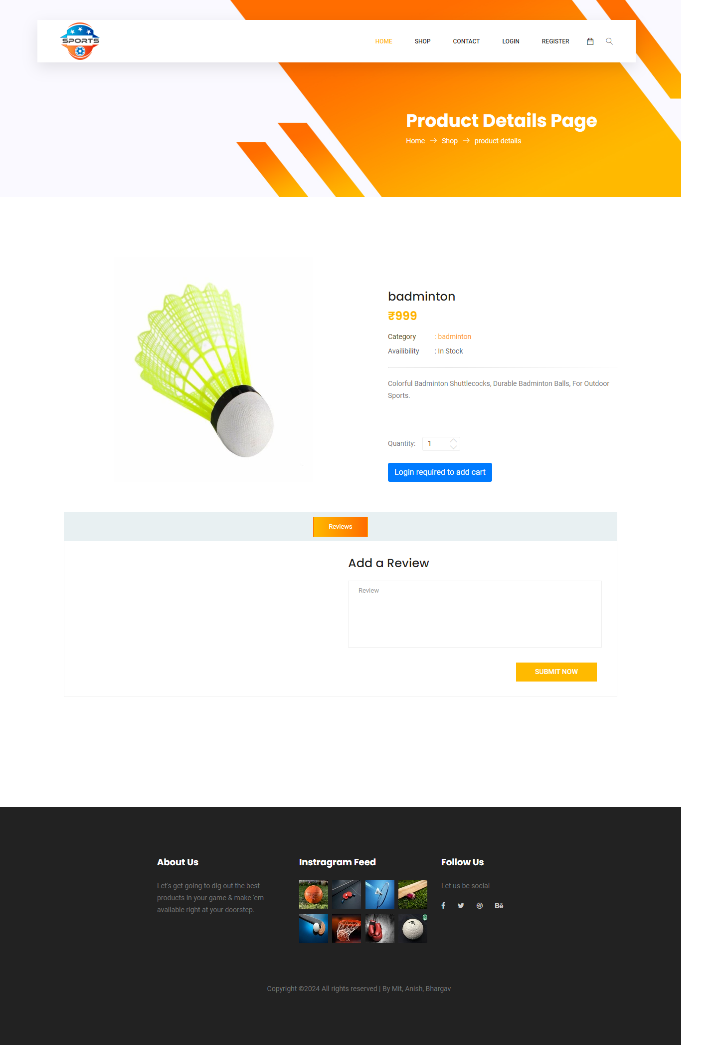
This is the Product detail page of our website.
1.4 Contact Page:
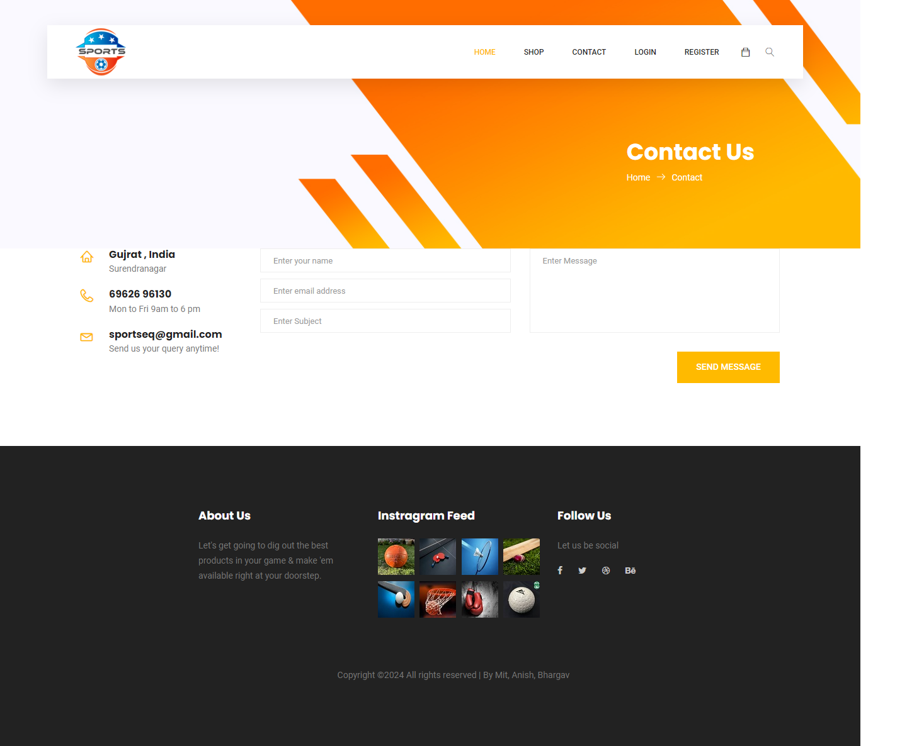

This is the contact us page of our website.

1.5 Register Page:
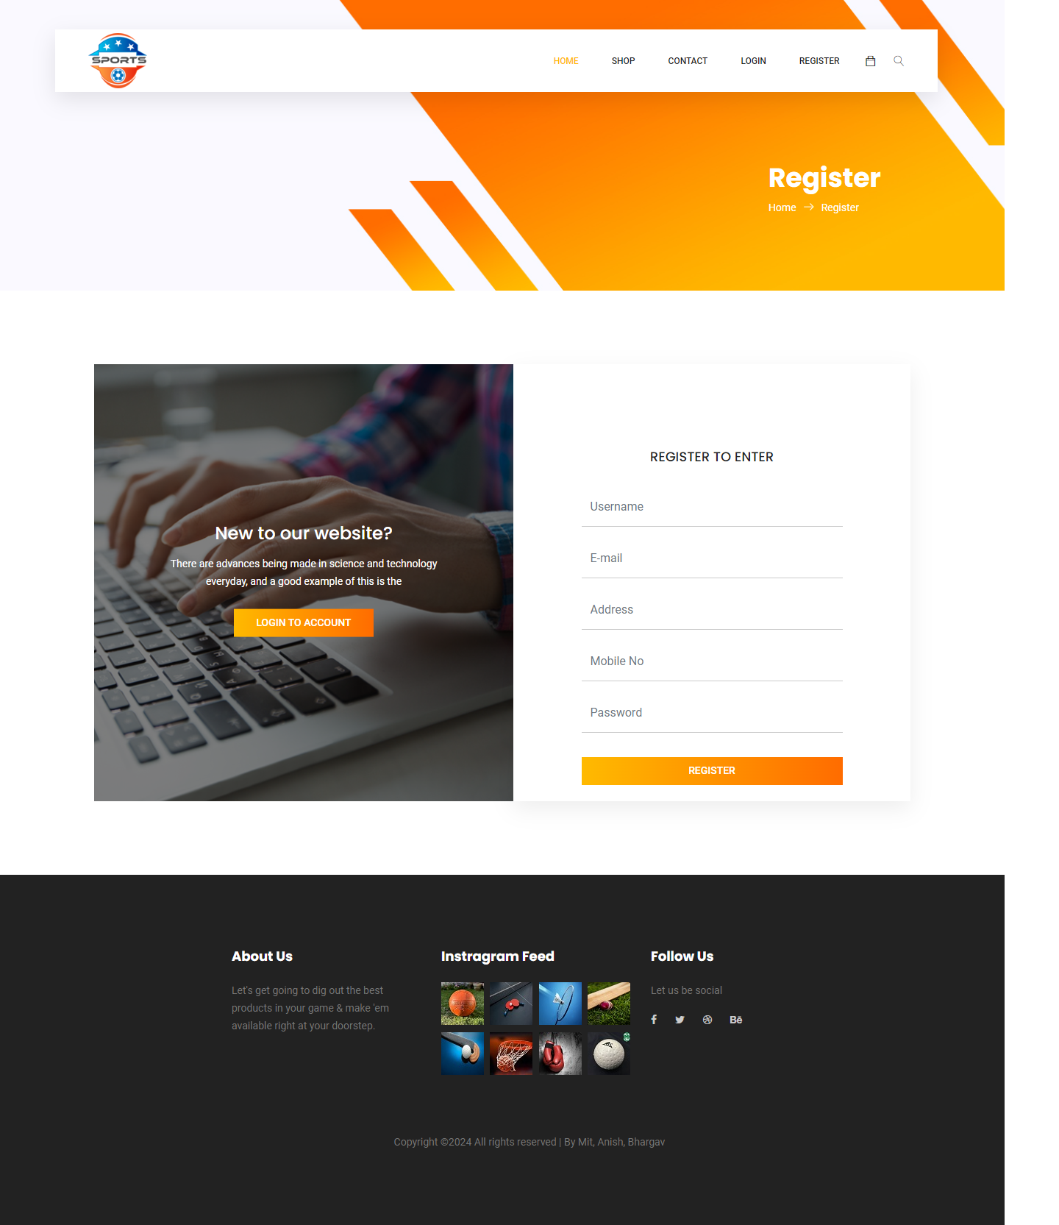
This is the register page of our website.

1.6 Login Page:
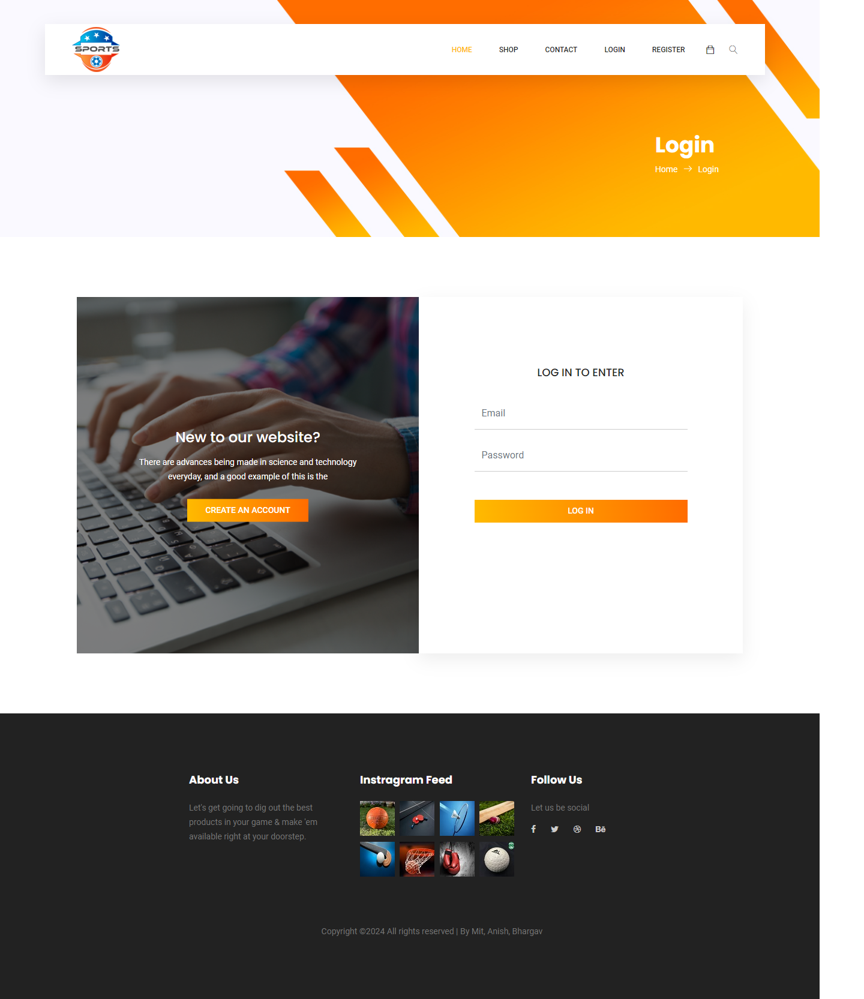
This is the Login page of our website.

1.6 Search Page:
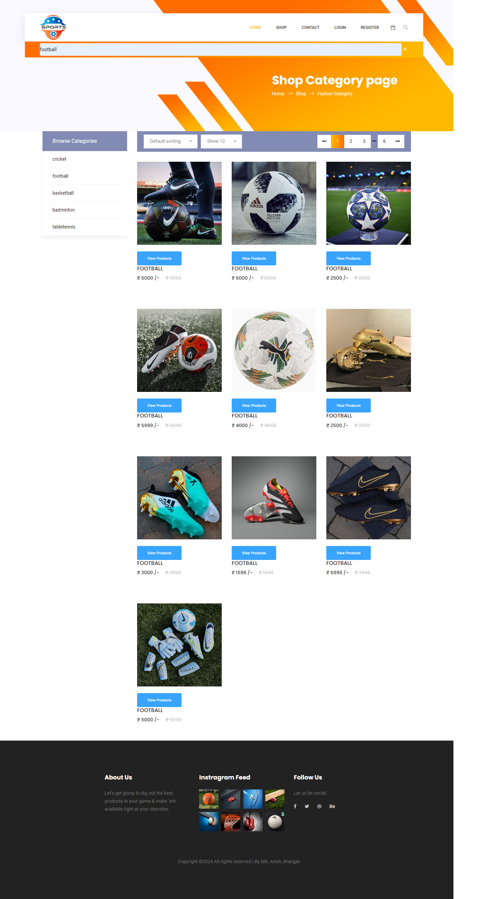
This is the Serach page of our website.

- REGISTER USER SIDE:
  - Register User Login Page
This is the Register User Login page of our website.

2.2 Register User Home Page

This is the Register user Home page of our website.

2.3 Register User Shop category Page
This is the Register user Shop category page of our website.

2.4 Register User Product Detail Page
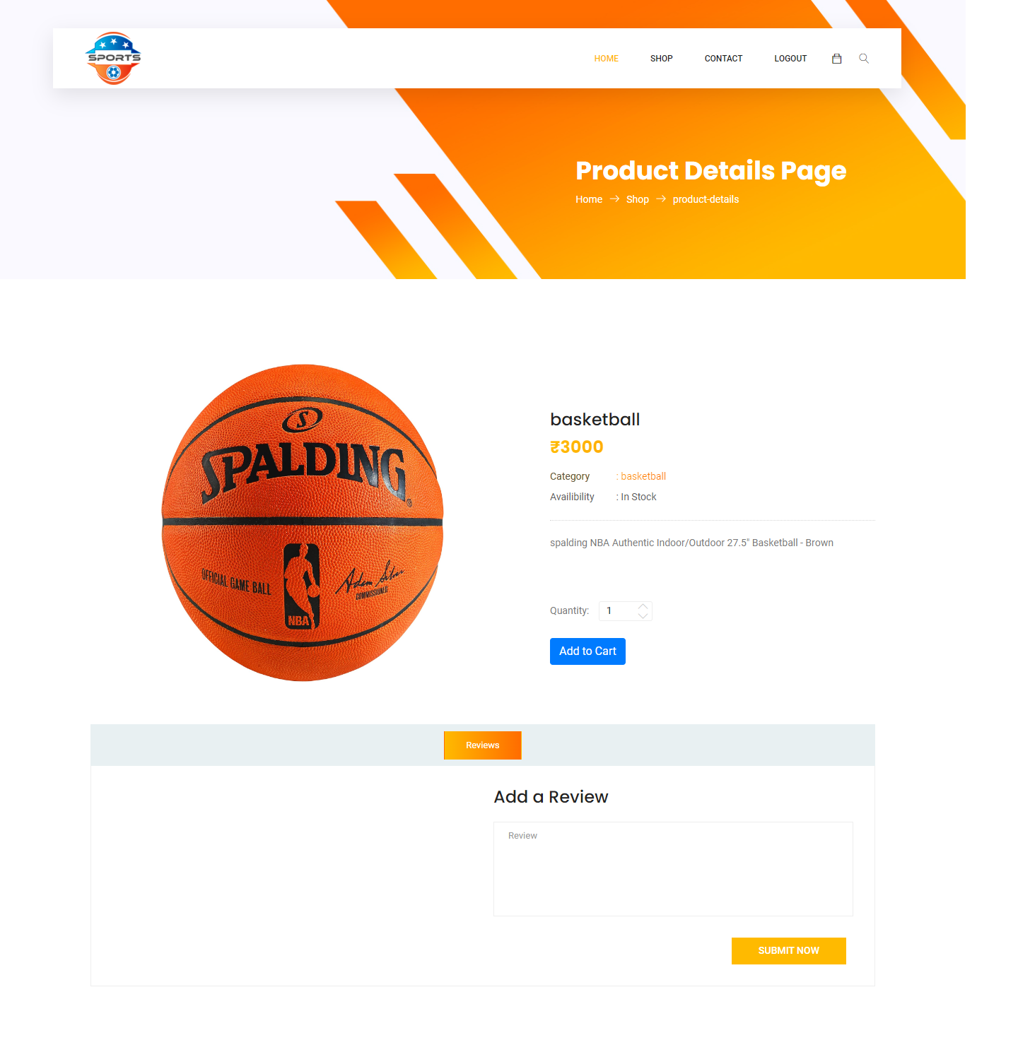
This is the Register user product Detail page of our website.

2.5 Register User Review Page
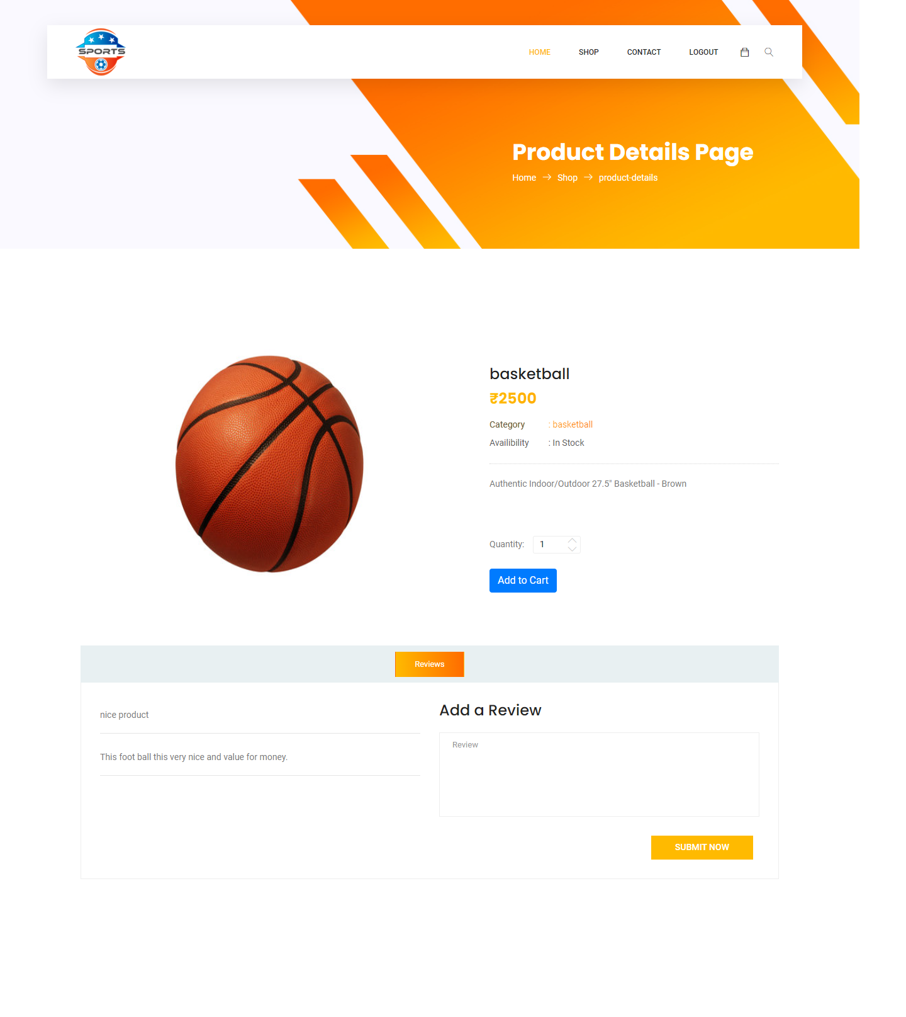

This is the Register user Review page of our website.

2.6 Register User Home Page

This is the register user contact us page of our website.
2.7 Register User Shopping Cart Page
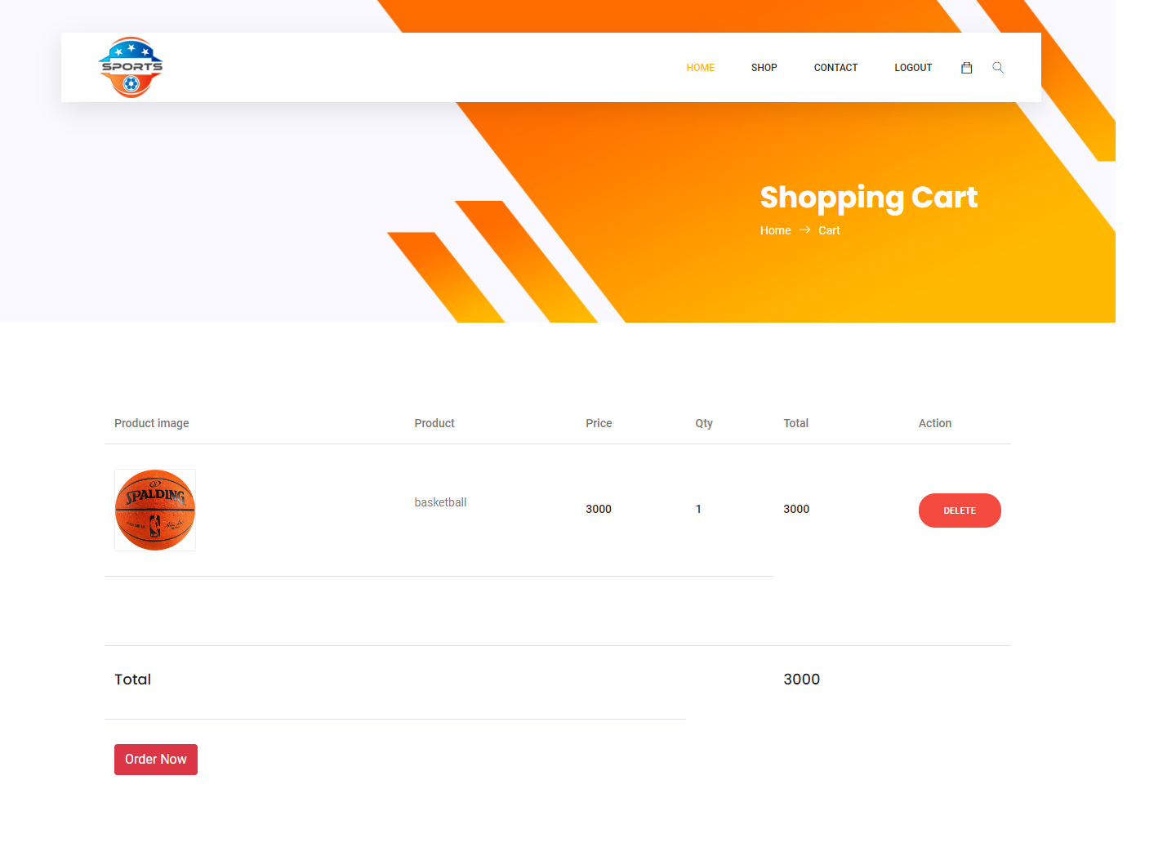
This is the Shopping Cart page of our website.

2.8 Register User Oder Conformation Page
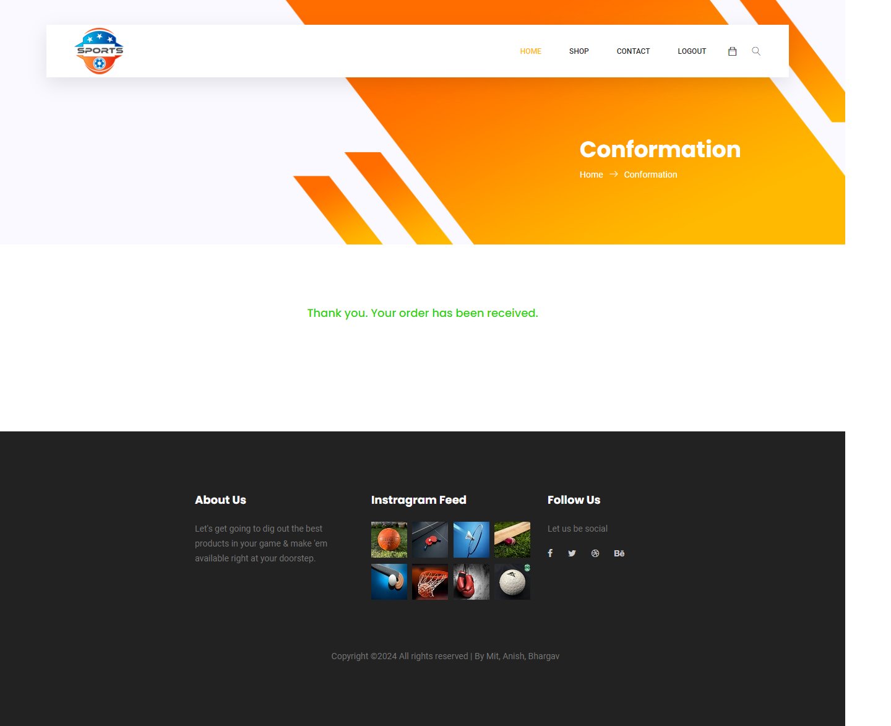

This is the Register User Order Conformation page of our website.

3. ADMIN SIDE:
3.1 Admin Login Page
This is the Admin Login page of our website.
3.2 Admin Home Page
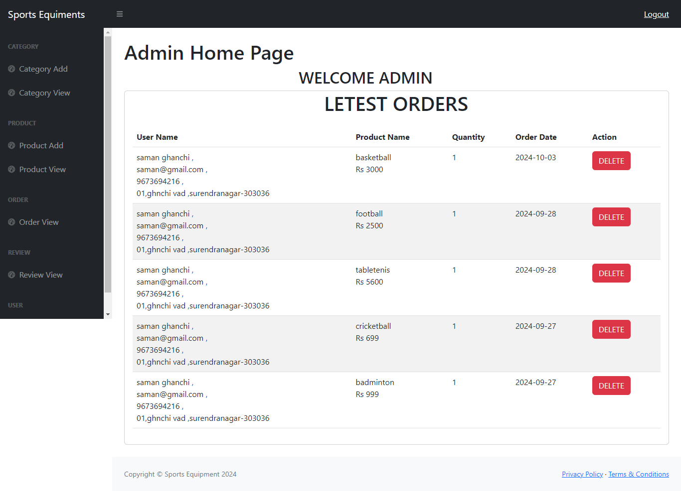

This is the Admin Home page of our website.

3.3 Admin Category Add Page
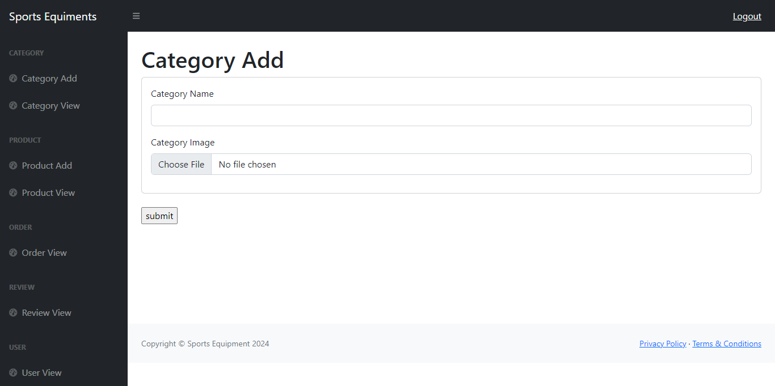

This is the Admin Category Add page of our website.

3.4 Admin Category View Page
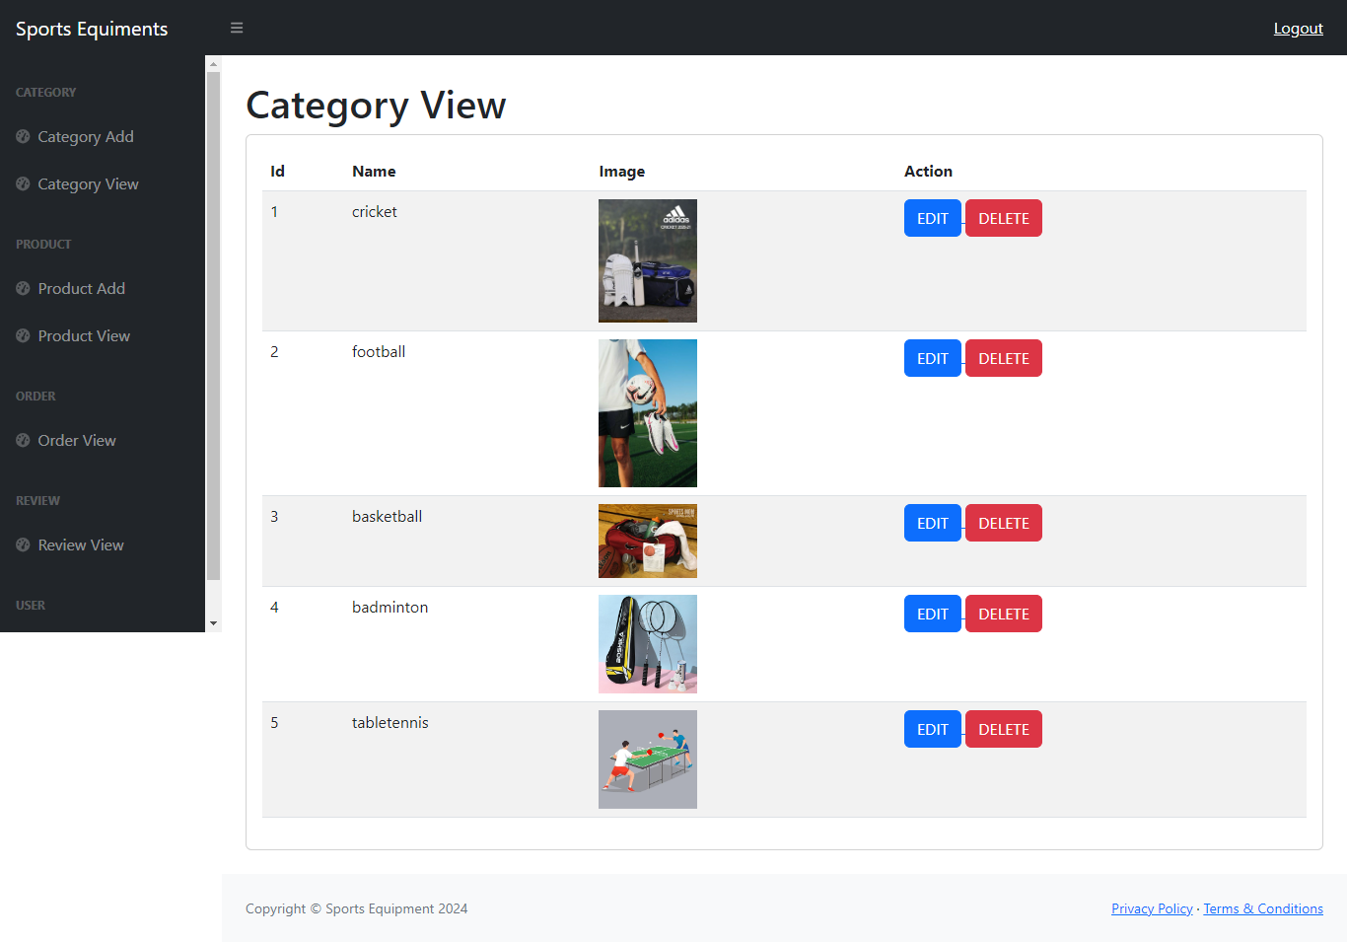

This is the Admin Category View page of our website.

3.5 Admin Category Edit Page

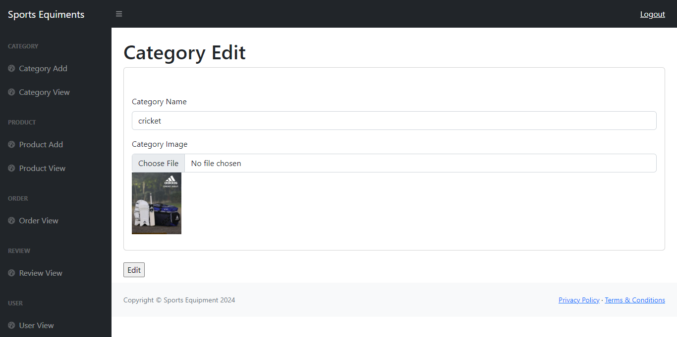
This is the Admin Category Edit page of our website.

3.6 Admin Product Add Page
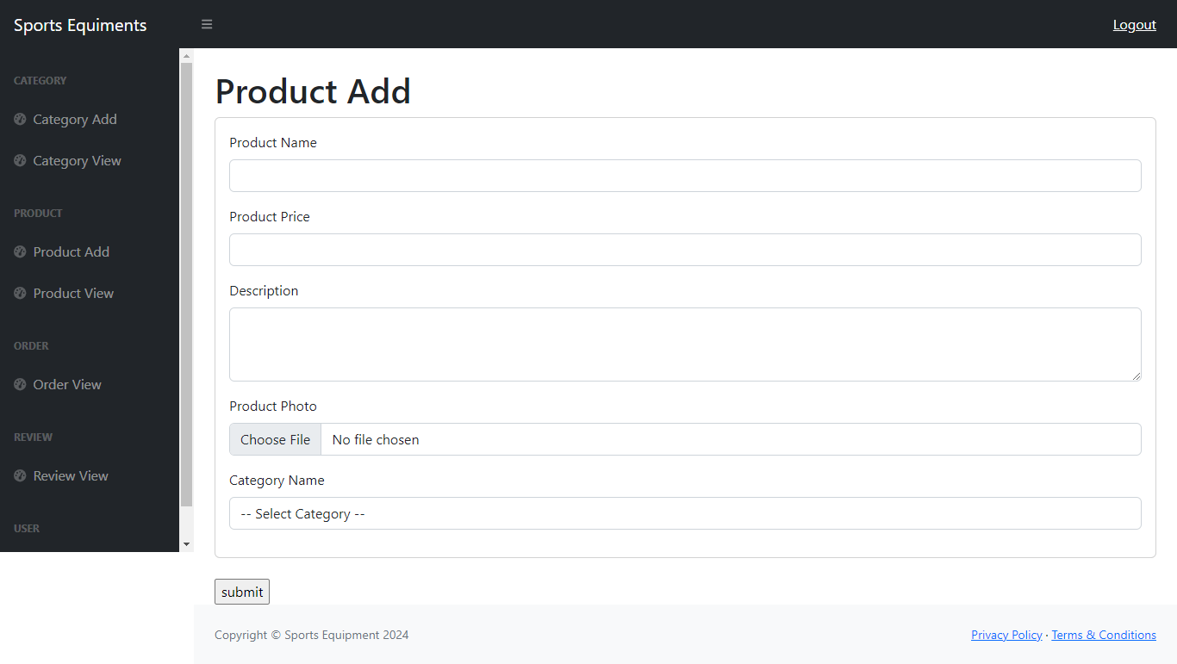

This is the Admin Product Add page of our website.

3.7 Admin Product View Page

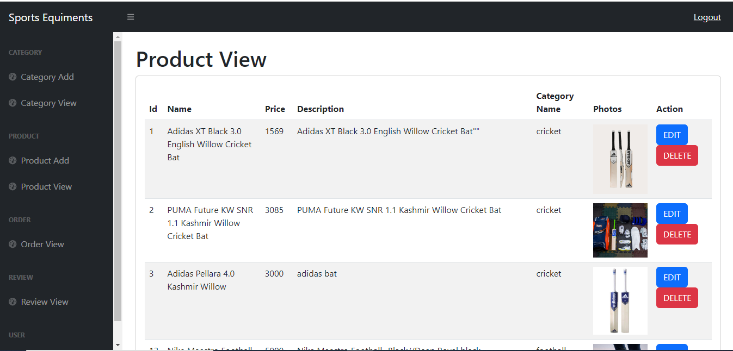
This is the Admin Product View page of our website.

3.8 Admin Product Edit Page
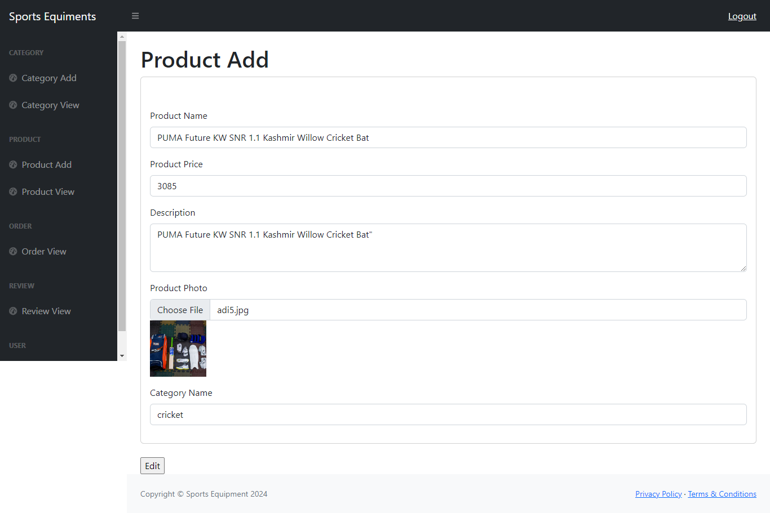

This is the Admin Product Edit page of our website.

3.9 Admin Order View Page

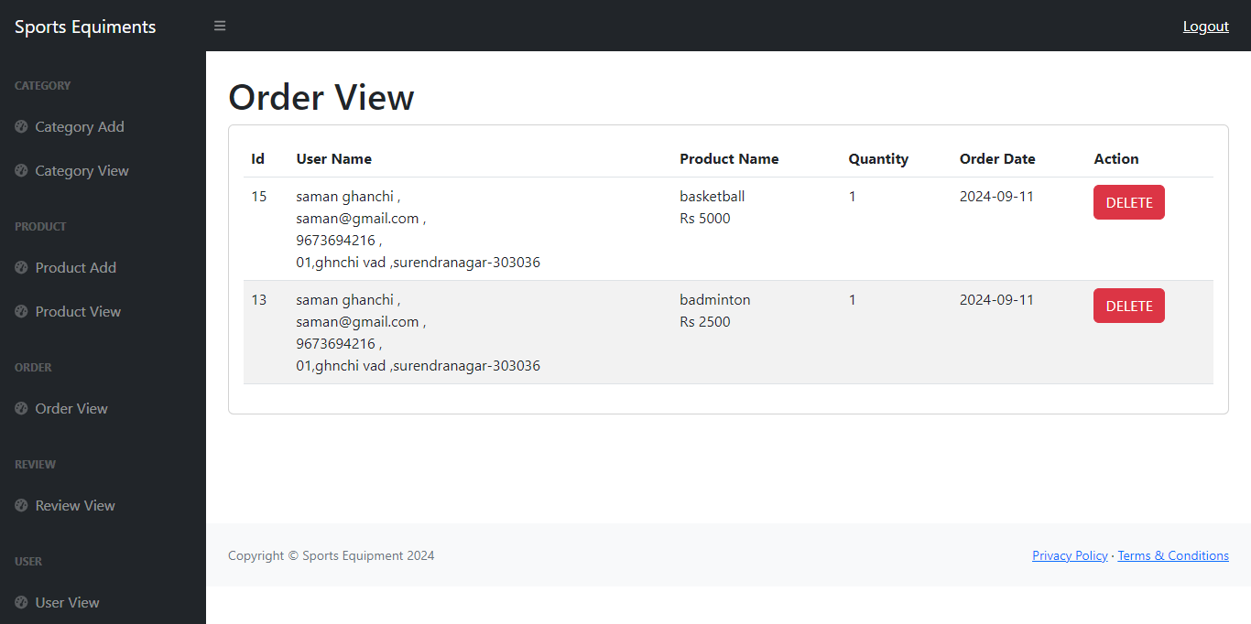
This is the Admin Order View page of our website.

3.10 Admin Review View Page
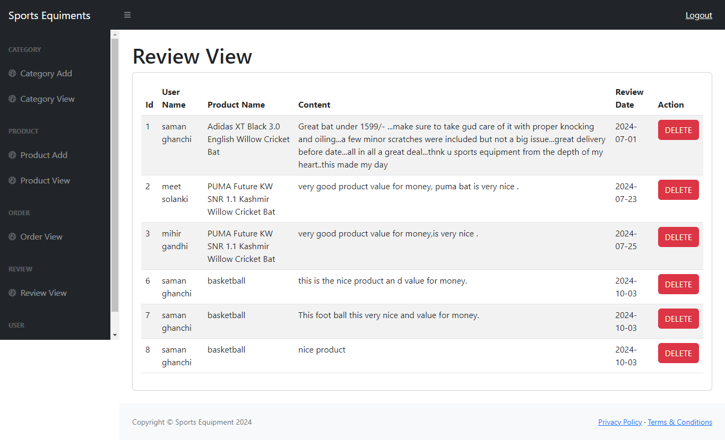

This is the Review View page of our website.

3.11 Admin User View Page
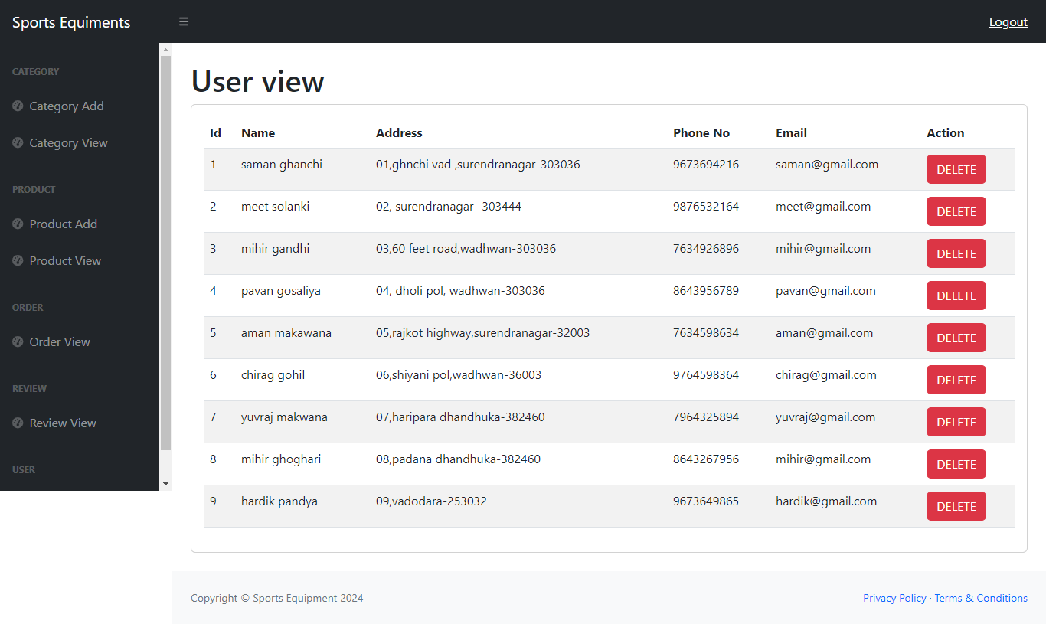

This is the Admin User View page of our website.

